**SENIOR PROJECT**

**ABU QUIZ**

Submitted by:

*Bilal Oskar*

*Cemre Ayik*

Project Supervisor: Dr.Faculty Member Tarek Khalifa

Faculty of Engineering

Antalya Bilim University

Spring 2018

|  |  |
| --- | --- |
| ABSTRACT ……………………………………………………………………... |  |
| 1 INTRODUCTION   …………………………………………………………… |  |
| 2 CONTENT OF THE PROJECT ……….…………………………………...…. |  |
| 2.1  Comparing Two System |  |
| 2.1.1 Disadvantages of existing system ………………………………... |  |
| 2.1.2 Objective of Proposed System………...……………………….….. |  |
| 3 DETAILS OF PROJECT……………………………………………………… |  |
| 3.1 Register ……………………...……………………………………….…  3.1.1 Administrators…...…………………………………………………  3.1.2 Faculty Member…………….………………………………………  3.1.3 Students……..……………………………………………………… |  |
| 3.2 Login………………………...…………………………………………… |  |
| 3.2.1 Faculty Member…………….………………………………………  3.2.2 Students……..………………………………………………………  3.3 Courses  3.4 Quizzes  3.5 Grades  3.6 Add Question  3.7 Browse Question  3.7.1 Create Quiz….…...…………………………………………………  3.7.2 Search Quiz………………….……………………………………..  3.8 Confirmation……………………………………………………………...    4 APP    5 E-R DIAGRAM  6 FUTURE  7 CONCLUSIONS …………………………………………………...………  8 SCREENSHOTS |  |
| REFERENCES ……………………………………………………………… |  |

**TABLE OF CONTENTS**

ABSTRACT

The Internet has become an increasingly important feature of the learning environment. The development of Internet technologies has raised the education level in all countries and it has changed the way students learn. 20 years ago, students had to spend hours in the library looking for the information, however today, it is much easier with the evaluation of technology.

Students can easily access almost every document on the internet like articles, research papers, newspapers and etc. They can have better and deeper understanding of the topics. That’s why it is very important for the present generation that they provide internet education for their young generations. This is our motivation for this Project.

INTRODUCTION

Our Project is Online Quiz System which is a web based application for multiple choice questions. Online Quiz System does not only replace paperwork but also releases the workload of faculty. It fulfills the requirements of the institutes to conduct the exams online. Students can give exam without the need of going to any physical destination. They can view the result from their mail. Professor will send results to each student mail address.

Thus, the purpose of the site is to provide a system that saves the efforts and time of Faculty. The main objective of online quiz is to efficiently evaluate the candidate thoroughly through a fully automated system that not only saves lot of time but also gives fast results

Probably, you can find more than thousands of quiz program on the internet. Human being finish already all addable features possibilities for any quiz system. The main objective of our Online Quiz System is to provide all the features prepared for our university. We did every feature with Mr. Tarek, but with the interfaces that don't scare its users.

CONTENT OF THE PROJECT

The main purpose of the system is to efficiently evaluate the candidate thoroughly through a fully automated system that not only saves a lot of time but also gives fast results and saves paper.

* It is a cost-effective and popular means of mass-evaluation system.
* The faculty members prepare the tests and questions for each exam.
* The candidates can login through their computers with their university e-mail and password which they created and then they can take the exam.
* The questions are shuffled in a random order so that possibilities for getting questions in the same order for the students who are besides, is very less.
* The system handles all the operations and generates reports as soon as the test is completed which saves the precious time of faculties spent on reviewing answer sheets.

Can be used anywhere any time as it is a web based application

COMPARING TWO SYSTEMS

The Existing system of conducting examination process is manual. It is a large man power process and is difficult to implement it at different platforms. It has so many problems. So, we introduce an online quiz system which is fully computerized. It helps educational institutions and corporate world to conduct exams to any number of candidates at a time, in an automated manner. It reduces the time consumption and workload that exist in the current system of examination. It also helps in storing the record of each examination and the results are also stored in the system. This makes the searching of the records easier than the existing system.

**Disadvantages of existing system**

* The existing systems are very time consuming.
* It is difficult to analyze the exam manually.
* Results are not precise as calculation and evaluations are done anually.
* Result processing after summation of exam takes more time as it is done manually.
* Recording results are another issue.

**Objective of proposed system**

* Economic and Technical feasibility
* Saving time and money
* User-friendly interface
* Eco-Friendly System (Prevent wasting of paper)
* It helps creating a question bank for the university which makes professors job easy.

DETAILS OF THE PROJECT

Register

Users of this system are classified into three categories:

* Administrators
* Faculty Members
* Students

**Administrators**

Administrators are responsible for management of system users, faculty members and students registration and etc.. Admin have ability to confirm or delete user. After admin confirmation system send an e-mail to the user. If admin delete the user, that user cannot enter system. We add admin from database and we gave ‘-1’ as a UserType. There is no way to register as a admin.

**Faculty Members**

Faculty Members adding their information’s from register part. After faculty members waiting for the admin confirmation. We create an admin account and confirmation part to make sure that user faculty member or not. After confirmation from admin, faculty member going login page and entering the system.

**Students**

Students adding their information’s from register part. After students waiting for the admin confirmation. We have 2 control-steps to understand user professor or not.

Firstly,

Our system checking user mail address. The users have to enter system with their university mail address. As you know students mail have extra ‘std’ inside. If student try to attempt entering from professor side. System will give error.

Secondly,

User might solve this ‘std’ problem and can try with fake mail address. At this point admin delete this attempt from our system. With this way, we make sure who register system is studying in our university or not.

After confirmation, student going login page and entering the system.

Courses

Firstly, students need to choose their courses for the currently semester from the listed courses. The list contains all the available courses for that semester. The system does not separate the courses as a specific department. We consider all students may want to choose any course from other departments. Courses should added to system database by administrator at the beginning of each semester. After students choose their courses, the faculty members who enter question for that course beginning of semester get notification about it and they can confirm the students or decline the students. When faculty members confirm the students, students can join the course.

Quizzes

In the quiz part, students see their quizzes which belong to the courses they choose.

For each quiz, they see the date and time which is created by the faculty members, and they can solve the quizzes in the available time period.. The students who complete quiz cannot saw answers and cannot reach the question answers. We create this case cause of these students make their quizzes out of school and they can communicate with each other. Our case not solving this but it helps us about correction of question. People who attempt cheating might give same answer but they will not know is correct or not in while. After students finished the quiz, their starting and ending time and the result of that quiz record to the database and send to the related faculty members.

Why does the system record the starting and ending time? Students tend to cheat and there are many ways to cheat for students. We thought that, if we know when students begin and end the quiz, maybe we can understand that student cheat or not. For example, if the faculty members prepare the quiz which takes maximum 30 min. but the students finished it in 1 hour or maybe 5 min. faculty member can see there is something maybe wrong with this student

Grades

After students finish the quizzes their results send to the related faculty members with show quiz button. Student results going professor with all details, Professor can saw every question student answer and if professor doesn’t want to interest with those information’s can focus only student grades. We make the calculation from 100-point system. As count of question divided with 100 and multiple with student correct answer.

Professor can focus student points with how many correct answer students have and can mail to student grade.

PROFESSOR

At the beginning, administrator should confirm the faculty members so they can access the system. After the faculty members got permission they can start to use system. Faculty members first responsibility is to choose which course they will teach. Then they can confirm the students who apply for that particular course

Add Question Part:

This part is the most essential part of system. Using this part, faculty members prepare their questions for the upcoming quizzes.

First of all, the faculty members choose the course which they want to prepare a question for from the list. The list already prepared by the administrator beginning at the semester. The list contains the courses that available for the current semester.

Secondly, they choose the topic for the question they want to add. Why the system has topics for each questions? At the beginning of the semester faculty members may add hundred questions that have ten different topics to the system. When the lecturer wants to prepare a quiz that quiz may contains a topic which is not covered yet. The system designed to prevent this. For this reason, there is a list of topics to add questions. When the lecturer wants to create a quiz, it is possible to decide which topics quiz can cover.

After that faculty members can add the questions. The system has two different options for this step, text or image. Faculty members can choose any image from their computer and add it as a question.

* If the image already has multiple answers like a, b and c, it is enough to just click the right answer from the choices below. After that the question and the correct answer add to the database.
* If the faculty members just want to choose one image like graph, schema for the question and type the other part of the question it is also possible.
* The other option is to type whole question.

One last step is choosing the level of the questions. System records the questions based on the difficulty level so after add the question, faculty members can choose the level of the question. System covers 3 level for now, easy, standart and hard so the quiz can contain every level. And finally, after they choose level of question they can approve the question and end up the insert section.

→Choose Course Name

→Choose Topic

→Add the question (Image or Text)

→Select the difficulty level

→Add the question to the database

Browse Question

This part helps faculty members to choose which question they may want to add the quiz. They can search the questions based on difficulty level or topic. With search they send to the class who set from professor.

Create Quiz

For creating a quiz, faculty members first choose the date and time. Lecturer wants s/he can put a time limit for the quiz so there may be deadline for it and students can prepare themselves. Students cannot take the exam any time other than the lecturer allow them. Secondly, faculty members choose the course and topics related with that quiz. With the Question Count, lecturer decide how many questions that topic includes. Professor may select 10 questions from topic 1 and may decide to make quiz with only 1 topic that point professor click create button or professor might want to make a 15 questions quiz with 5 different topic. In this case professor select count of question from every topic and create after for each topic after finish create part with search button professor will see the quiz system send and also it goes students directly. Finally, questions will be prepared randomly as many as the number of decided.

Search Quiz

Faculty members choose the course and then click the search button. They will see the quiz they created in create part and this going directly to the students. Our first goal with this project put a edit part for search. Professors can delete questions or whole quiz from that edit part. This is most need part of our system if its decide use for our university.

Confirmation part:

This part was hard part of the system. This part is connected with the students’ courses part. After students decide which course they will register, the related faculty members get a notification about that students. These notifications come to this confirmation part.

As we mentioned a professor might give more than 1 course for this reason we detect professor and their course with questions. If professor enter question a course beginning of semester that course get add to professor confirmation part. Because professors only add questions for their class.

Faculty members have a list of students who they want to join the course they teach. If the faculty members allow the student they confirm it, otherwise they decline the student. As a result of this confirmation process, a class will occur. The class contains all the students who take that particular course for the current semester. Faculty members send the quiz to this class. Instead of sending it separately for each student. The results come from this class directly send to the faculty members.

APPLICATION

App kisminda kullanicilar telefonlarindan sistemizi web formasyonu ile ayni dogrultuda kullanabilir. Programimizin kullanilmaya karar verilmesi durumunda playstore ve appstore da indirmek icin hazir bulunduracagiz. Kullandigimiz bootstrap sayesinde sadece app formatina oturtarak hazirladigimiz application sistemimizdeki butun fonksiyonlari desteklemektedir.

Application un basilica faydalari elinde bilgisayar olmayan kullanicilarin tarihi gecmekte olan sinavlarini yapmalarinda fayda saglar.

Fakat sistemimizde henuz future kapsaminda dusundugumuz momentary ve vote partlari icin buyuk kolaylik saglamasi planlanmistir. Bu kisimlarda ogrenciler ve hocalar ayri sekillerde app formatindan fayda saglarlar.

Vote kisminda hocalar dan ziyade ogrenciler icin kolaylik saglanir. Ogrenciler gelen anketleri hizlica cevaplandirarak hocalara hizli donus saglayabilir.

Momentary kisminda ise aslinda isimiz tamamen application ile

Hocalar dersi anlatirken daha onceden olusturduklari soruyu yada ders esnasinda olusturdugu soruyu ogrencilere gonderir ve ogrenciler ders aninda telefonlarindan sisteme girerek soruyu cevaplandirir. Bu cevaplari oylama olarak hocaya geri donduruyoruz. Hoca gelen oylamayi hizlica telefonundan gorup dersin gidisatini belirleyebilir.

Momentary

In this part to be developed, the students respond to the instant questions added by the professor during the lesson by telephone with their application. On this page, the correct answer can be seen with the percentage of gore created, which shows how much student is understood by the class of the subject that is explained at the moment of the lesson. The professor can look at the graph so that he can solve more problem related with this topic. The topics that students do not understand at the moment of the course can be understood more quickly.

Vote

Questions organized by professors may be voted on by the student in the unanimous vote. With this voting, it is possible to understand which subjects the students want to take the exam. In this case, we can reach which topic selected and professors can focus for the other topics.

Lab

In this section professors will preapare quiz for lab section. In 2 hours class professors might use 1 hour for quiz in laboratory. The professors can do the first hour lesson and the second hour can do the test in the laboratory. Students can saw their answers directly from quiz page and they can ask to the asistant their questions.It will prove students with topics in Lecture. They can reach those quizes after to work their exams.

In normal quiz system student cannot saw their question or results.Only they can see is the result sending from professors.

Ilk oncelikli eklenicekler ;

Ogrenci course sayfasina liste

Bu listede edit sansi (dersi ekleme cikarma )

Prof browse question kismina edit

Search kismina edit sorulari silme ve sorulari yollamak icin ayri button

**REFERENCE**

SCREENSHOTS

Login

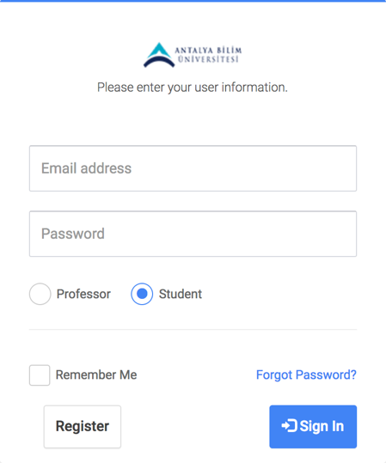

Register

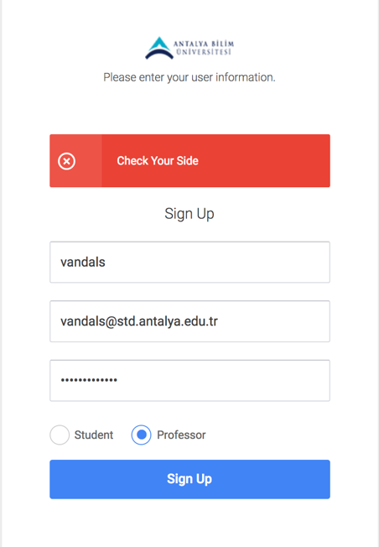

This image shows us a user that attempt professor side register with std mail.

Admin

Home Page of Admin

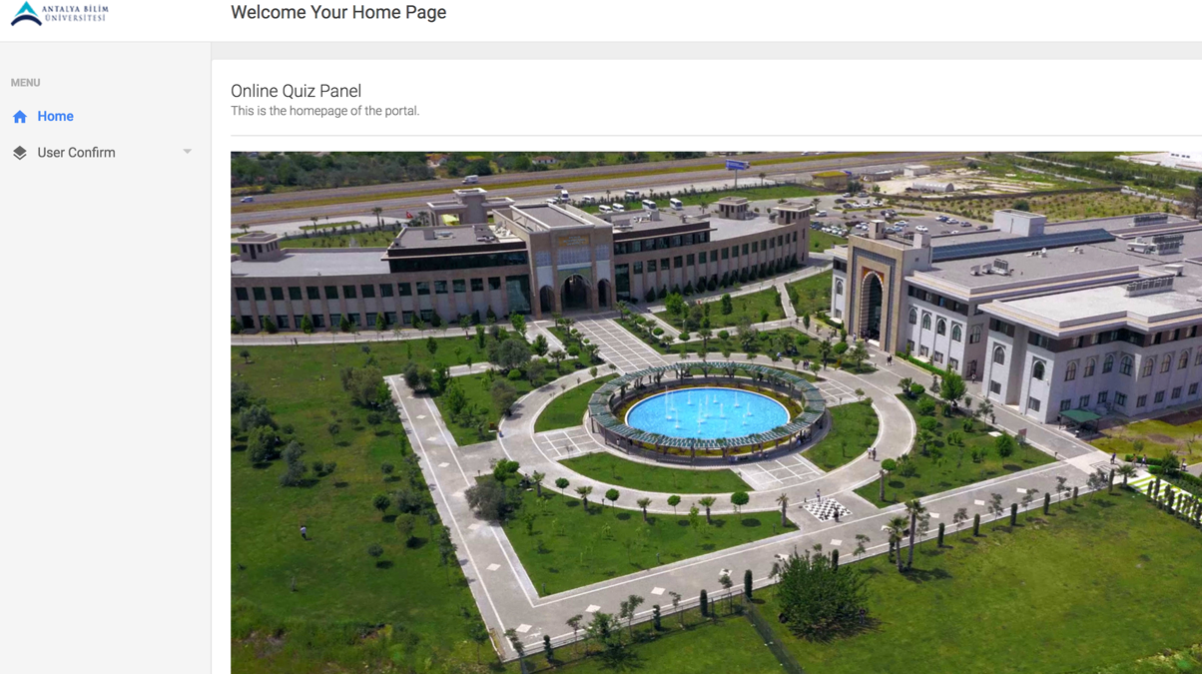

User Confirm

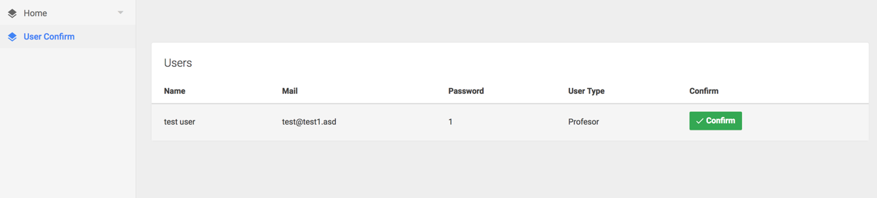

Students

Home Page of Students

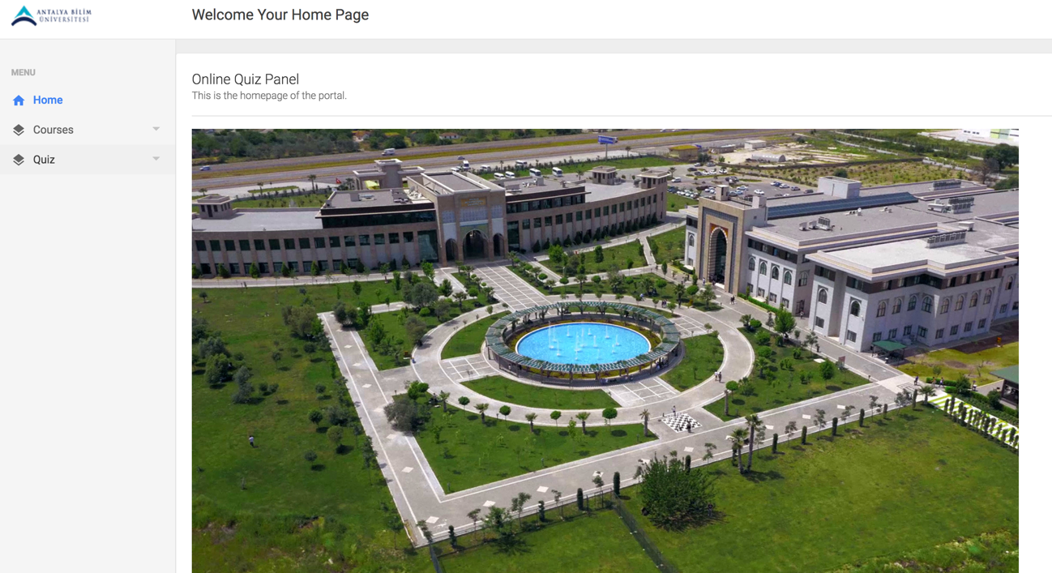

Courses

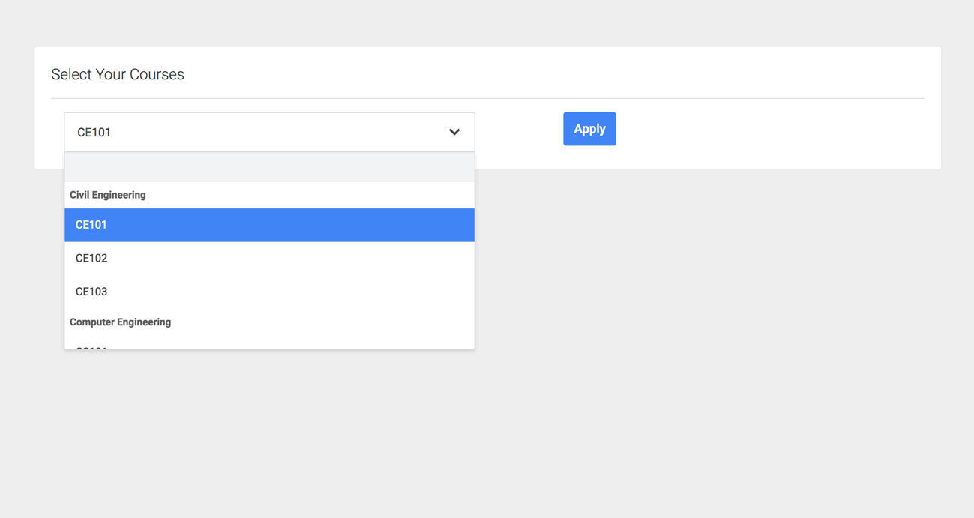

Student apply their courses for momentary semester.

Quiz

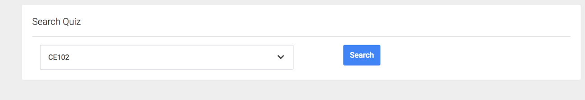

This segment is empty. After professor send a quiz that course name coming to this radio button. User search that course and quiz coming to the same page.

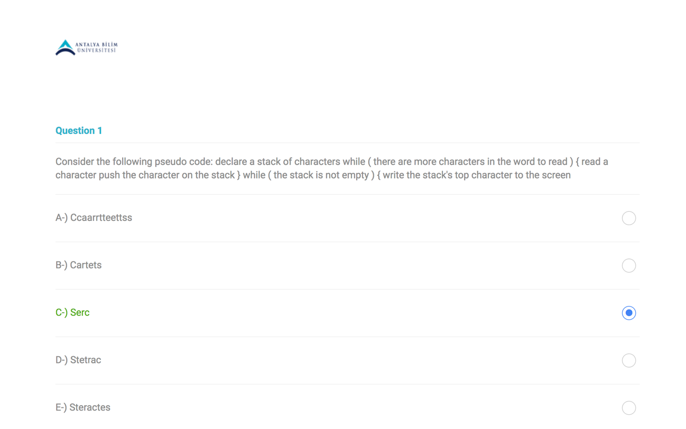

Professor

Home Page of Professor

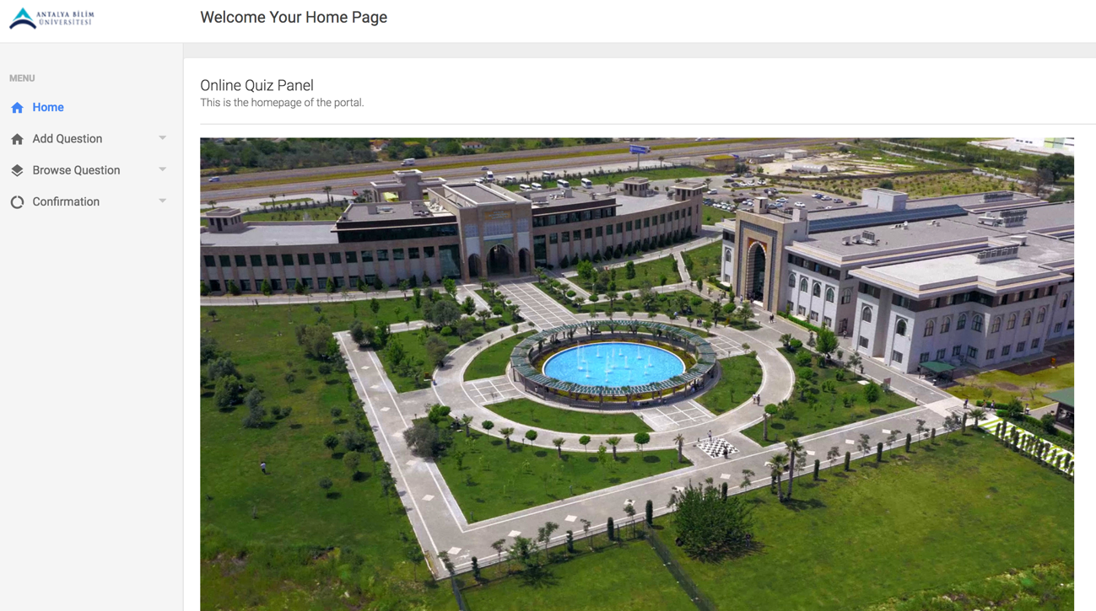

Add Question

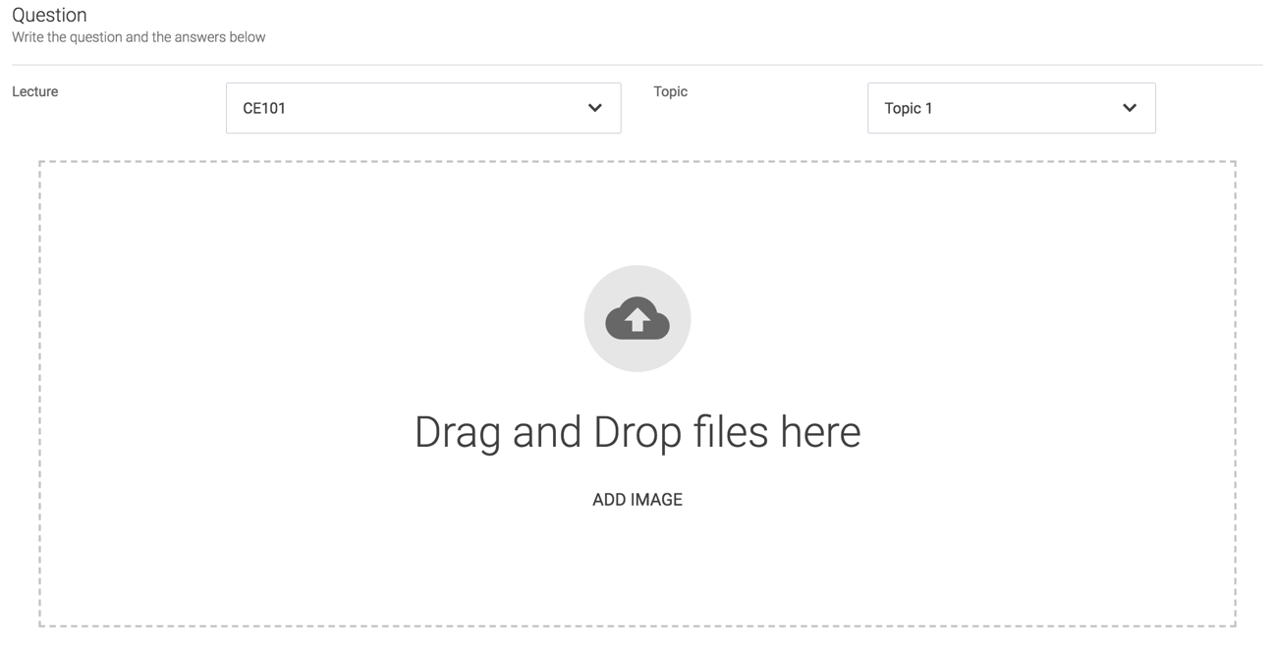

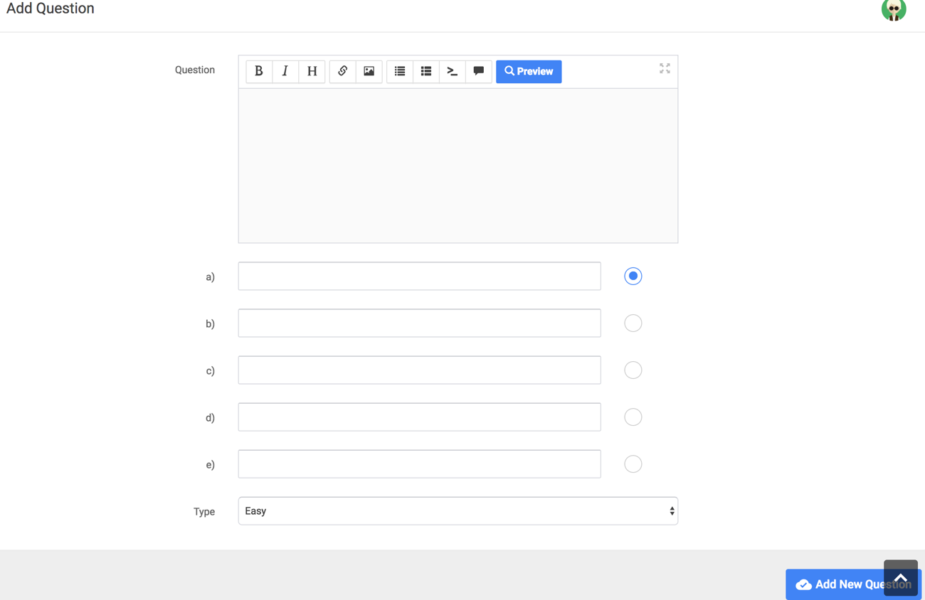

Browse Question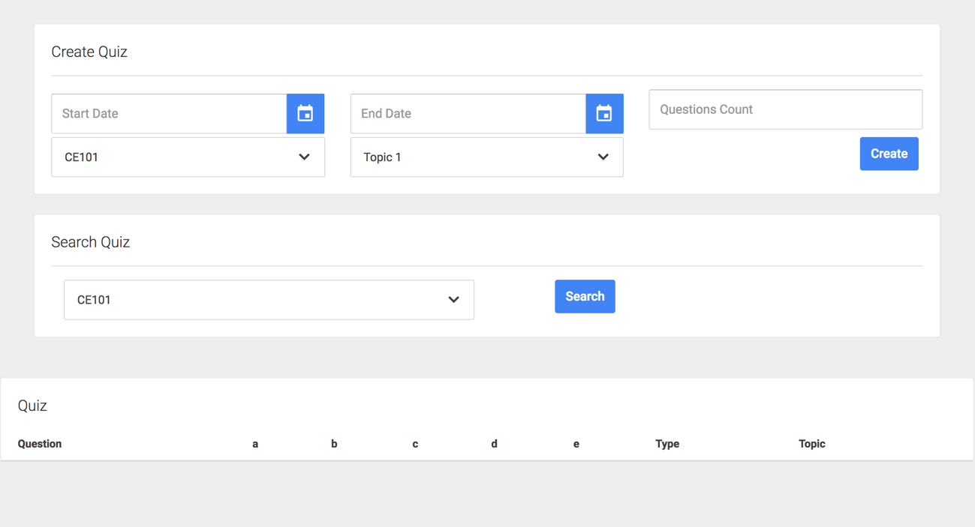

Confirmation

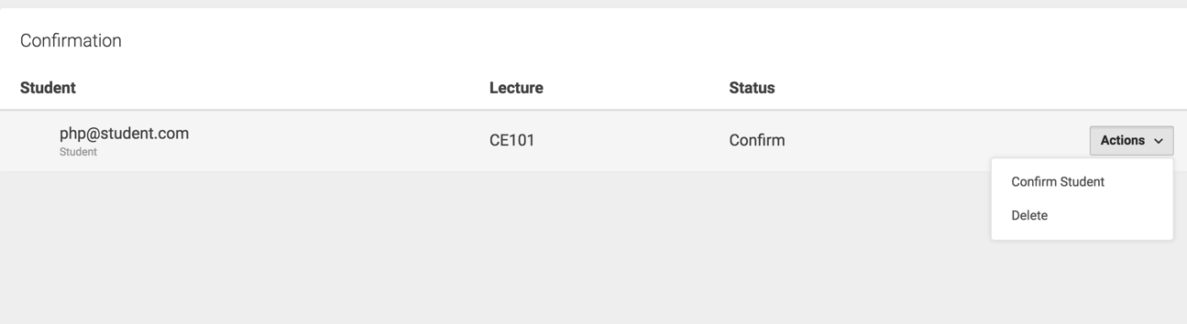

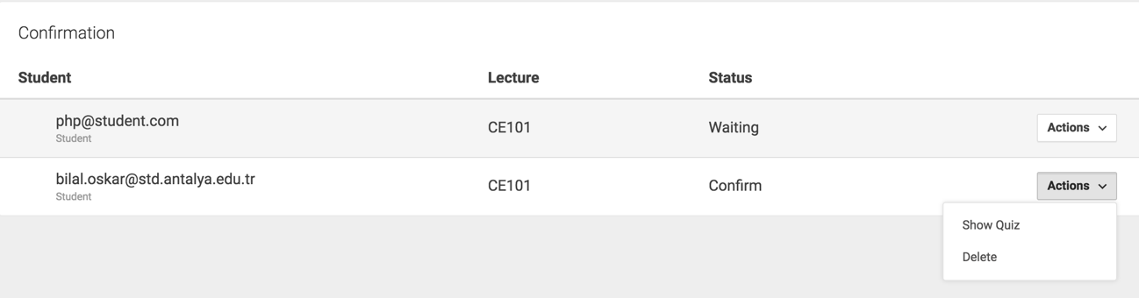

Show Quiz

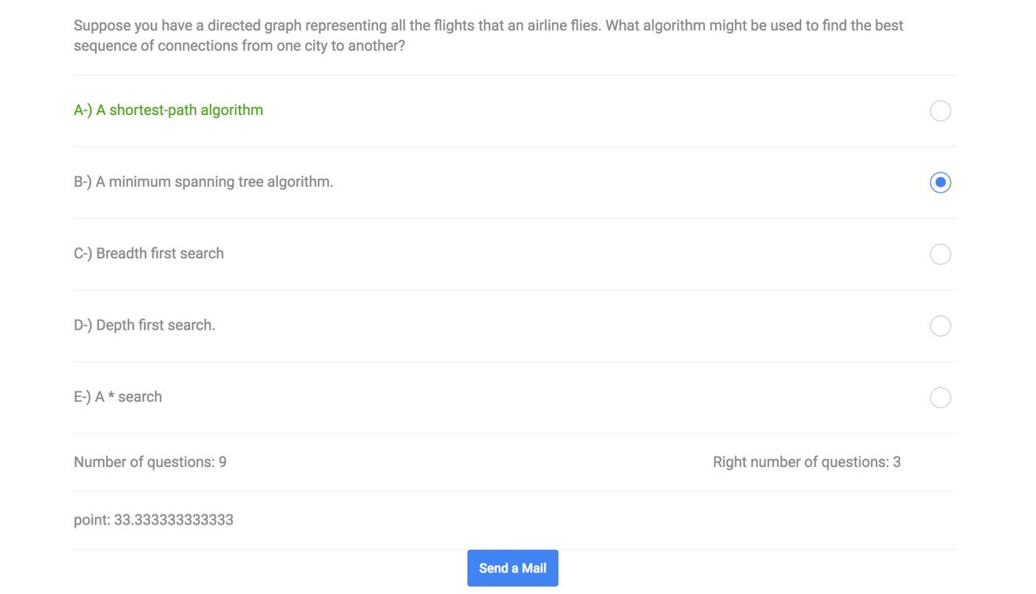

App

